Problem Statement:

You work for XYZ Corporation. Your corporation wants to launch a new web-based application and they do not want their servers to be running all the time. It should also be managed by AWS. Implement suitable solutions.

Tasks To Be Performed:

1. Create an Elastic Beanstalk environment with the runtime as PHP.

2. Upload a simple PHP file to the environment

Create an Elastic Beanstalk environment with the runtime as PHP.

Go wo AWS Console

Create Environment and Configure Envirnmnet

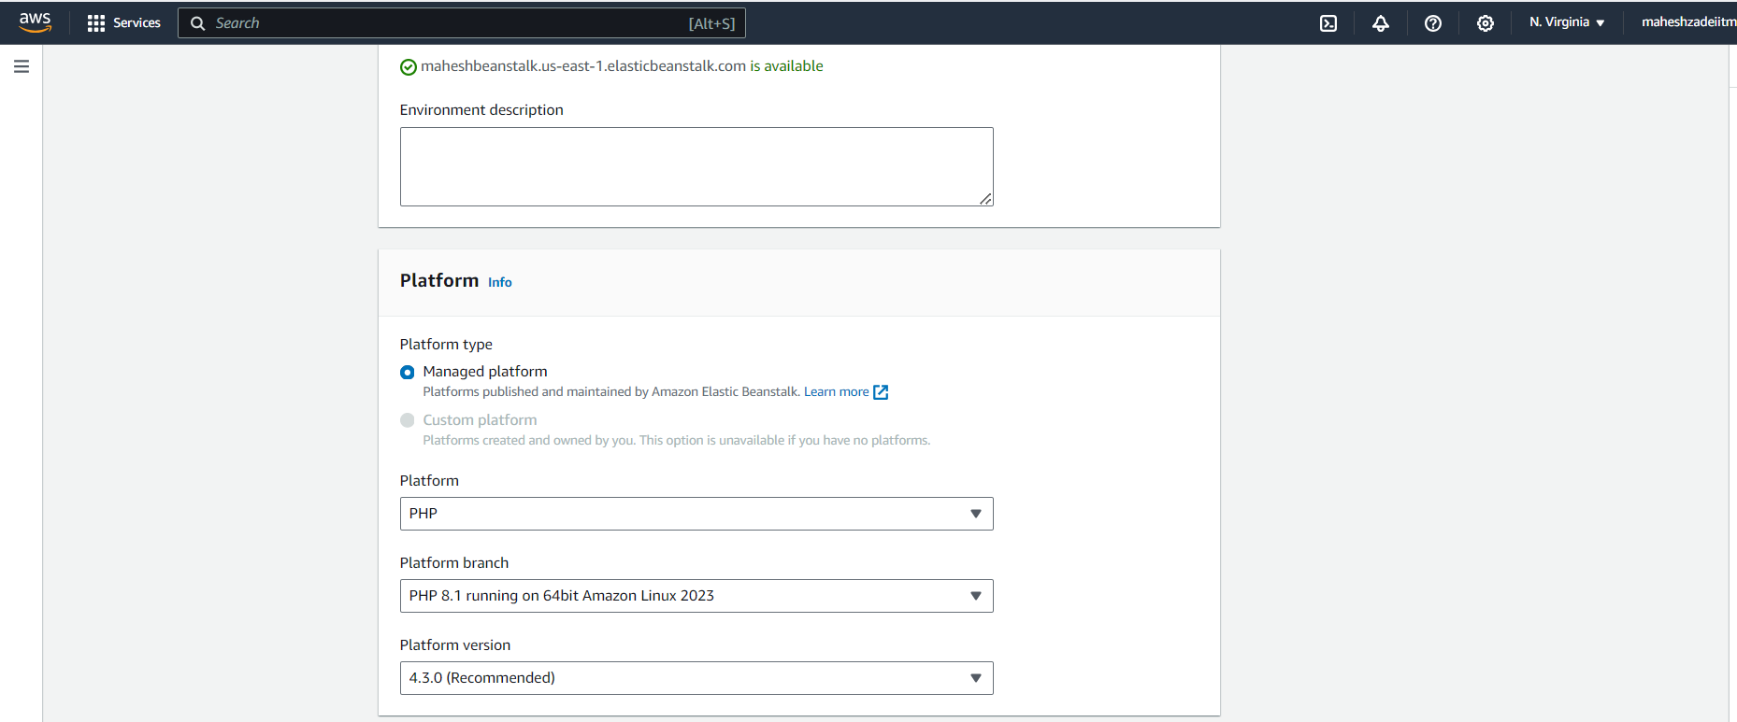

Click on next

Keep the remaining settings as it is

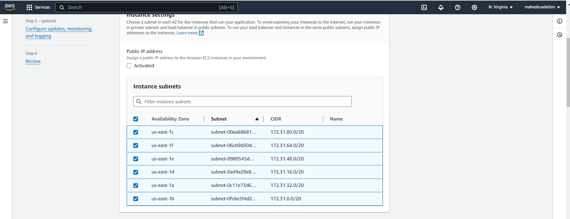

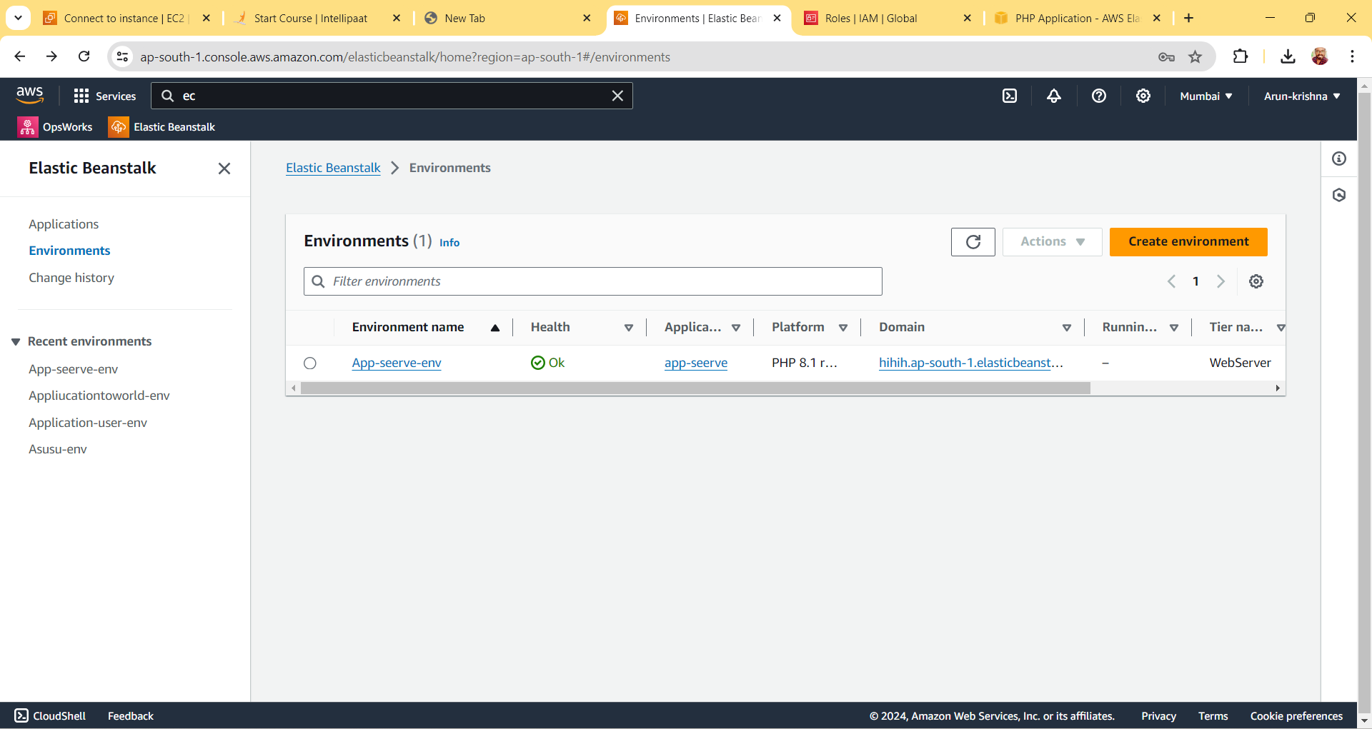  
  
  
  
  
  
  
  
  
  
  
  
Slect Default Security Group

Keep the remaining setting as it is and click on next

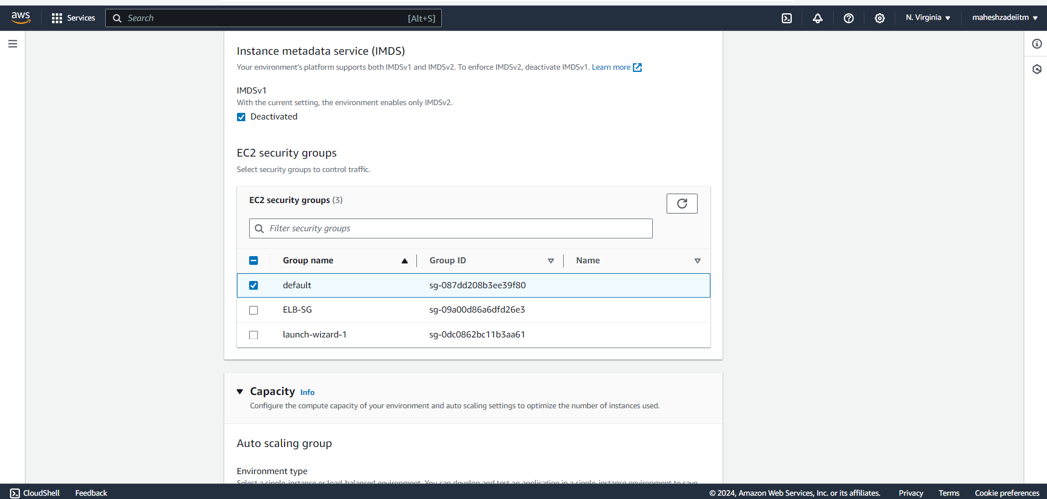

Click on Submit

Copy the Public IP pof the Ec2 Instacnes

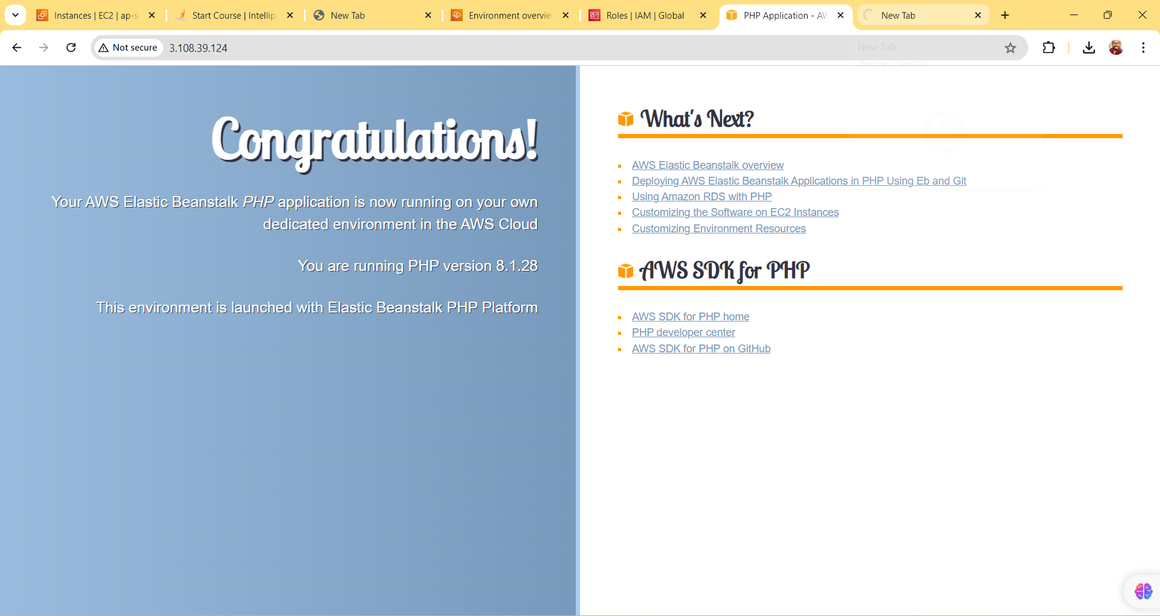

Copy Public IP from EC2 Instance and Paste in Browser

upload a simple PHP file to the environment

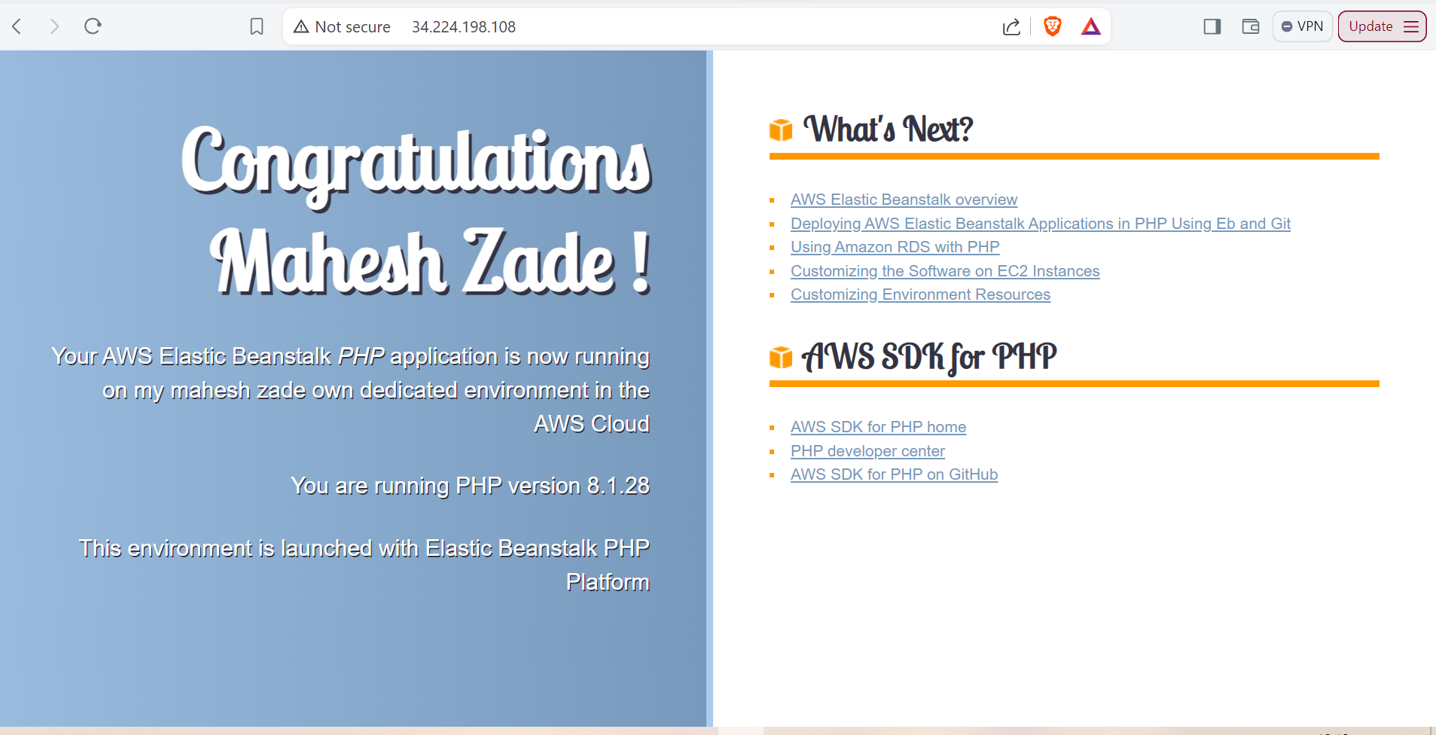

Thanks